# PROFESSIONAL TRAINING REPORT

**At**

# Sathyabama Institute of Science and Technology (Deemed to be University)

Submitted in partial fulfillment of the requirements for the award of Bachelor of Engineering Degree in Computer Science and Engineering By

**D. Sai Pranay**

**REG. NO. 39110264**



# DEPARTMENT OF COMPUTER SCIENCE AND ENGINEERING

**SCHOOL OF COMPUTING**

**SATHYABAMA INSTITUTE OF SCIENCE AND TECHNOLOGY**

### JEPPIAAR NAGAR, RAJIV GANDHI SALAI, CHENNAI – 600119, TAMILNADU

**SATHYABAMA**

### INSTITUTE OF SCIENCE AND TECHNOLOGY

**(DEEMED TO BE UNIVERSITY)**

### Accredited with Grade “A” by NAAC

(Established under Section 3 of UGC Act, 1956)

JEPPIAAR NAGAR, RAJIV GANDHI SALAI CHENNAI– 600119

[**www.sathyabama.ac.in**](http://www.sathyabama.ac.in/)

DEPARTMENT OF COMPUTER SCIENCE AND ENGINEERING

**BONAFIDE CERTIFICATE**

This is to certify that this Project Report is the bonafide work of **D.Sai Pranay** (Reg. No:

### 39110264) who carried out the project entitled “EMPLOYEE MANAGEMENT SYSTEM” under my supervise

January 2022 to April 2022.

Internal Guide

Dr.R.Sathyabama Krishna

**Head of the Department Dr.L.LAKSHMANAN.,M.E.,Ph.D.**

## Submitted for Viva voce Examination held on

**InternalExaminer ExternalExaminer**

**DECLARATION**

I,**D. Sai Pranay** hereby declare that the project report entitled **Employee Management System** done by me under the guidance of **Dr**. .**R.Sathyabama Krishna** is submitted in partial fulfillment of the requirements for the award of

Bachelor of Engineering Degree in Computer Science and Engineering.

**SIGNATURE OF THE STUDENT**

**DATE: 10/09/2022 SIGNATURE OF THE STUDENT**



**PLACE: CHENNAI**

**ACKNOWLEDGEMENT**

I am pleased to acknowledge my sincere thanks to **Board of Management of SATHYABAMA** for their kind encouragement in doing this project and for completing it successfully. I am grateful to them.

I convey my thanks **to Dr. T. Sasikala M.E., Ph.D, Dean,** School of Computing**, Dr. S. Vigneshwari, M.E., Ph.D. and Dr. L. Lakshmanan, M.E., Ph.D., Heads of the Department of Computer Science and Engineering** for providing me necessary support and details at the right time during the progressive reviews**.**

I would like to express my sincere and deep sense of gratitude to my Project Guide **Dr.** .**R.Sathyabama Krishna** for his valuable guidance, suggestions and constant encouragement paved way for the successful completion of my project work.

I wish to express my thanks to all Teaching and Non-teaching staff members of the **Department of Computer Science and Engineering** who were helpful in many ways for the completion of the project

# CERTIFICATE:

**TABLE OF CONTENTS**

**CHAPTER NO TITLE PAGE NO**

LIST OF FIGURES 7

ABSTRACT **8**

1  **INTRODUCTION** 9

1.1 About the Architecture 9

1.2Reasons to choose the following 10

**2 APPLICATION SAMPLES 12**

**3 Application Flow 15**

3.1Commands used 15

**4 Flow chart 16**

**LIST OF FIGURES**

**FIGURE NO. FIGURE NAME PAGE NO.**

**2.1 Login page 12**

**2.2 Wrong Credentials 12**

**2.3 Admin page 13**

**2.4 Create Employee 13**

**2.5 Create project 14**

**2.6 Assigning Project 14**

**2.7 Employee page 14**

**4.1 Flow Chart 16**

**Abstract**

The application that are building is Employee management system. It has features to add employee and add Task. Admin can create Project and he can also create Employees. The created employees can view their Projects assigned by the Admin. The admin can also delete the projects assigned to employees. The application will be widely used in the organizations which are looking to manage their employees and their projects assigned. Also, to understand the work status of their employees

**INTRODUCTION**

**About the Architecture:**

The Architecture that we are following has three components.

Which are as follows:

**. Front End**

**. Back End**

**. Database**

Reason for following is, in case we want to scale the existing application it would make our job easier to aggregate our features into the desired component.

**The technology stack is as follows:**

**Front end - React JS, Html and CSS**

**Backend - Python Flask**

**Database - MySQL**

**Reasons to choose the following.**

For the front end we are using React, the reason being its flexibility to reuse the components. We declare the components which can be further used in various parts of the application.

For example,

The component of employee listing can be reused for the projects listing. So, reactjs gives us the flexibility for reusing the components.

For the Backend, we are opting for the Python-Flask. Flask is a micro framework which is built on python. Flask framework is suitable for applications which have short and crisp versions of components. Although we are using DB efficiently, API calls are limited. So flask is optimal for such cases.

Having said that, Netflix is also using Flask for a few components in their Application like subscription service of their platform has flask involved in it. It’s also easy to use too.

For the Database we are using, MySQL. As we are dealing with employee status management we want to make use of database for most write operations. So MySQL is handy for such cases and writes immensely faster.

The Micro service Architecture

As we are running each component,

Python flask

React Js

MySQL

Into different ports,

Flask is running on 5000,

React Js on 3000 and MySQL on 3306.

We can consider the above Architecture as a micro service Architecture.

Benefits of the above Architecture,

• Easy to destruct

• Easy to debug

• Logging

• Scalability

Disadvantages

• Sometimes it could be hassle to setup Hassle to setup

**CHAPTER 2 APPLICATION SAMPLE**

**Login page:**

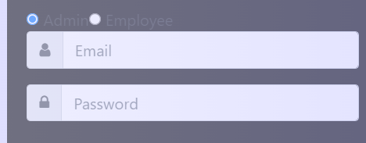

FIG 2. 1

**Wrong Credentials:**

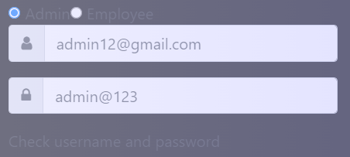

FIG 2. 2

**Admin Page:**

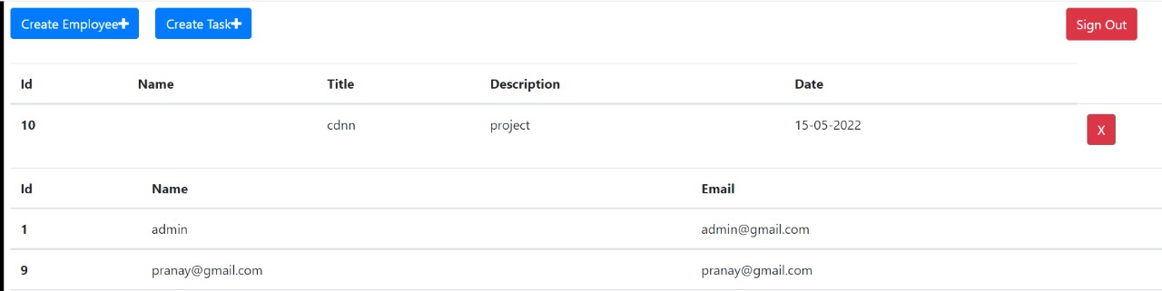

FIG 2. 3

**Create Employee:**

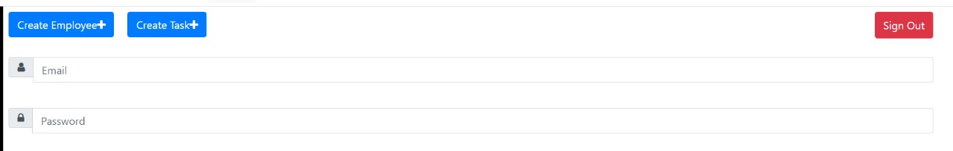

FIG 2. 4

**Create Task:**

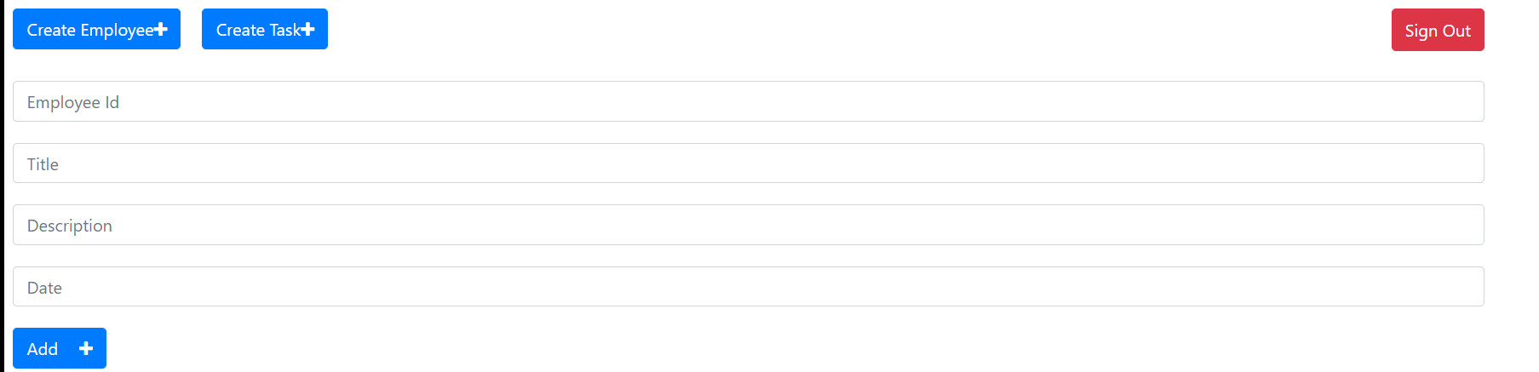

FIG 2. 5

**Assigning Project:**

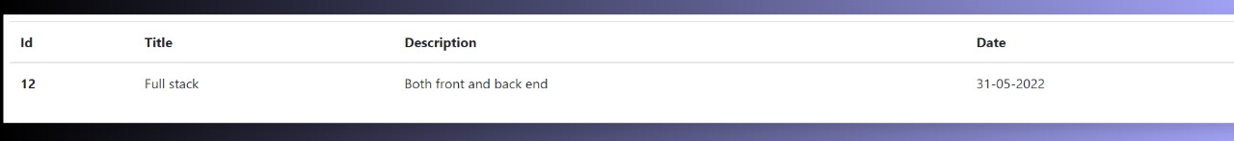

FIG 2. 6

**Employee page:**

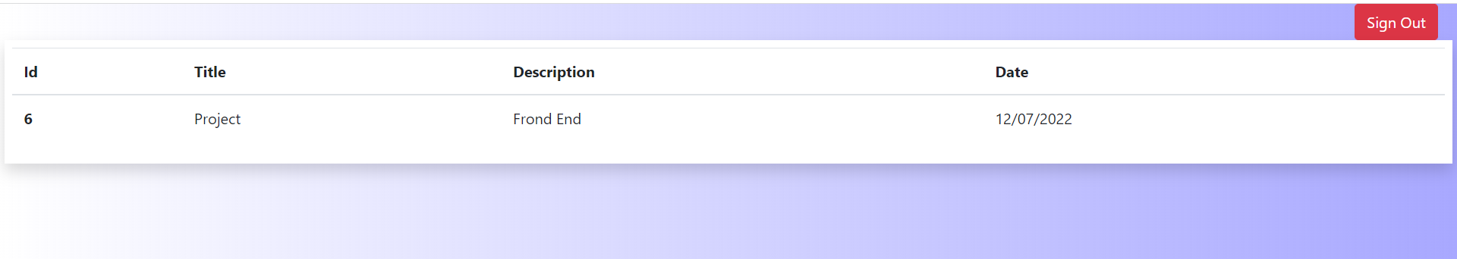

FIG 2. 7

**Chapter 3**

**Application Flow:**

-> Start the React JS , which has the UI

-> It runs on port 3000 ( by default, but can be changed)

- Commands used are:

-> first cd into the folder which has package.json

-> npm install

-> npm start

-> Then start the API, app.py

-> It runs on port 5000 ( by default, but can be changed)

**3.1**

**Commands used are:**

->Creating an environment to run python-flask

-> pip install virtualenv

-> venv\scripts\activate

->pip install Flask

-> pip install mysql-connector-python

-> pip install -U flask-cors

**Chapter 4**

**Flow chart:**

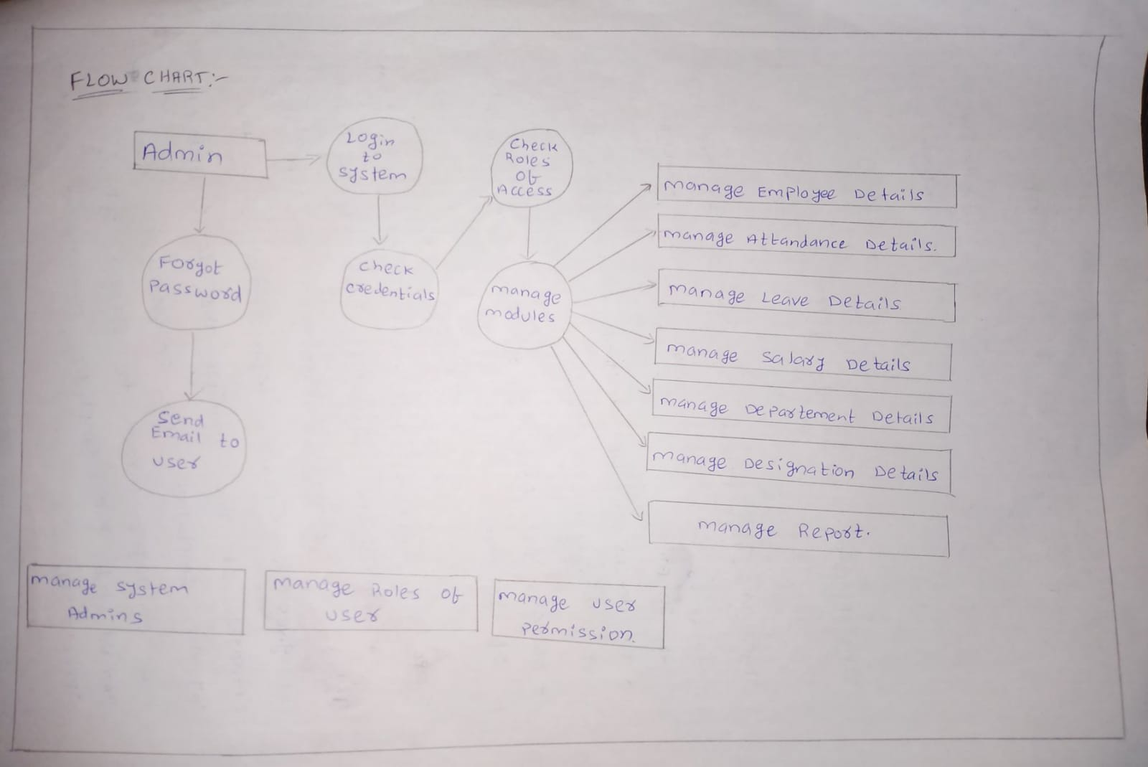

Github link:

https://github.com/saipranay9889/Employee-Management-System.git